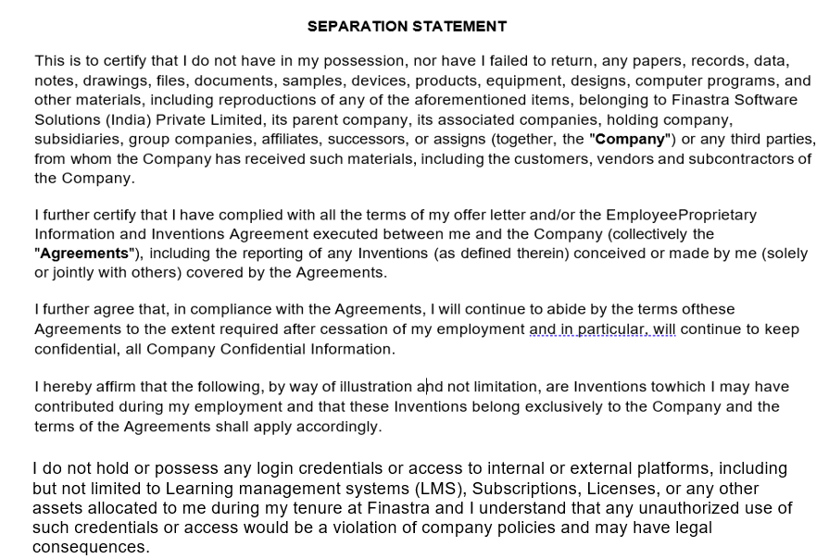

✔
No Inventions or improvements (Yes/No)
See below (Yes/No)

Whether Additional Pages Attached (Yes/No)

Date: 06/07/2026

The Employee’s Signature: Aarti Muddebihal

The Employee's Name and Number: Aarti Muddebihal , 8669388510

[Please insert details]

